Advent and Children
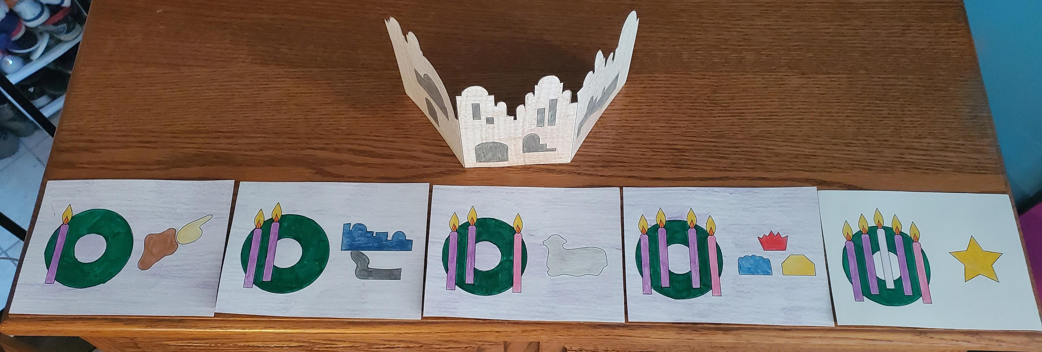
“Stories are like the air we breathe. They are invisible and taken for granted until they are missing, then we quickly discover we can’t live without them. This is because stories tell who we are and they unite us.” ~Jerome Berryman, Stories of God at Home
Did you know that the Bible began by storytelling? Stories passed on through families, through generations. Storytelling is one of the earliest ways that humans made meaning from their world. Storytelling and wondering within it draws us into the story of Christmas. It is the story of God with Us.
The book Stories of God at Home by Jerome Berryman is a way to give families stories of faith to tell their children at home. If you aren’t sure how to approach talking to your kids about faith—Godly Play at Home is a terrific place for you!
Godly Play, Advent, and Children: “Storying” Christmas
At St. Paul’s, we have been using Godly Play to share the story of God’s People with our youngest Sunday School classes. Children in Pre-K, Kindergarten, 1st, and 2nd grade have been hearing stories of God’s People and then wondering about their own place in those stories. The stories they hear belong to them, and always have, even before the children were born. They belong to each child because the children are a part of the story. They ARE God’s People. And children are overflowing with wonder!
Advent and Christmas are perfect times to wonder because they are mysteries—and mysteries are something that we can walk right by and not even know they are there if we don’t take time to slow down and look for them.
Miracles are all around us. Christmas is the miracle of miracles. Storytelling about the birth of Christ, and wondering about it together, is an amazing gift to give a child.
How-To Prepare Your Materials and Tips to Storytelling
In your packet, you will find a set of cards that you can color—along with a suggestion sheet of how the cards could look. You’ll also find a “script” for the story, God With Us. Each week in Advent has its own story—and each week, you will add a card to the story.
My suggestion is to prepare the storytelling cards as a family. Let your kiddos help color them. Talk about how Advent is the season in the church that leads up to Christmas, and that it is a time for waiting. Waiting is HARD for kids! (I remember—do you?) One of the best ways to get ready is to take the time to slow down each week and hear the story—and if you do this on Sunday, you can combine the storytelling with lighting your family Advent wreath.
Tell the story slowly—don’t rush the pace. If it feels like you’re talking really slowly, then you’re doing it perfectly. After the story—make sure to wonder together. There are wondering questions in the script just in case you were wondering. You can ask the questions… and be comfortable with silence as everyone considers their answers. There are no right or wrong wondering answers…. you can support their wondering with “hmm ...I wonder ...” And feel free to wonder along with them! Because as adults, we don’t have all the answers. And that’s okay. Actually, it’s better than okay. It makes the children more comfortable to ask questions and wonder when the adults around them ask questions and wonder, too.

