St. Paul’s Episcopal Church
Noah & Sara’s Pledge
2019 Annual Pledges
All gifts are valued!
Listed below in ascending order is every St. Paul’s household pledge for 2019:
$100.00
$120.00
$120.00
$150.00
$200.00
$246.60
$250.00
$250.00
$300.00
$300.00
$300.00
$300.00
$300.00
$360.00
$360.00
$360.00
$400.00
$420.00
$420.00
$480.00
$480.00
$500.00
$500.00
$500.00
$500.00
$500.00
$500.00
$500.00
$500.00
$500.00
$504.00
$513.75
$520.00
$520.00
$520.00
$520.00
$520.00
$600.00
$600.00
$600.00
$600.00
$600.00
$600.00
$600.00
$600.00
$600.00
$600.00
$600.00
$600.00
$600.00
$600.00
$600.00
$650.00
$660.00
$700.00
$700.00
$720.00
$720.00
$720.00
$735.00
$780.00
$780.00
$850.00
$900.00
$924.00
$960.00
$1,000.00
$1,000.00
$1,000.00
$1,000.00
$1,000.00
$1,000.00
$1,000.00
$1,000.00
$1,040.00
$1,040.00
$1,040.00
$1,040.00
$1,040.00
$1,040.00
$1,200.00
$1,200.00
$1,200.00
$1,200.00
$1,200.00
$1,200.00
$1,200.00
$1,200.00
$1,200.00
$1,200.00
$1,200.00
$1,200.00
$1,200.00
$1,200.00
$1,200.00
$1,200.00
$1,200.00
$1,200.00
$1,200.00
$1,200.00
$1,200.00
$1,200.00
$1,200.00
$1,200.00
$1,233.00
$1,250.00
$1,300.00
$1,300.00
$1,320.00
$1,350.00
$1,375.00
$1,400.00
$1,400.00
$1,440.00
$1,440.00
$1,500.00
$1,500.00
$1,500.00
$1,500.00
$1,500.00
$1,500.00
$1,500.00
$1,500.00
$1,560.00
$1,560.00
$1,560.00
$1,600.00
$1,620.00
$1,800.00
$1,800.00
$1,800.00
$1,820.00
$1,820.00
$1,820.00
$1,820.00
$1,970.00
$1,976.00
$2,000.00
$2,000.00
$2,000.00
$2,040.00
$2,080.00
$2,080.00
$2,100.00
$2,100.00
$2,100.00
$2,200.00
$2,400.00
$2,400.00
$2,400.00
$2,400.00
$2,400.00
$2,400.00
$2,400.00
$2,400.00
$2,400.00
$2,400.00
$2,500.00
$2,600.00
$2,600.00
$2,654.00
$2,700.00
$2,800.00
$2,800.00
$2,860.00
$2,901.19
$3,000.00
$3,000.00
$3,000.00
$3,000.00
$3,000.00
$3,000.00
$3,000.00
$3,000.00
$3,000.00
$3,000.00
$3,000.00
$3,120.00
$3,120.00
$3,250.00
$3,300.00
$3,500.00
$3,500.00
$3,500.00
$3,600.00
$3,600.00
$3,600.00
$3,600.00
$3,600.00
$3,600.00
$3,600.00
$3,780.00
$3,900.00
$3,900.00
$3,900.00
$3,900.00
$4,000.00
$4,000.00
$4,000.00
$4,500.00
$4,560.00
$4,800.00
$4,800.00
$4,800.00
$5,000.00
$5,000.00
$5,000.00
$5,000.00
$5,000.00
$5,000.00
$5,000.00
$5,000.00
$5,200.00
$5,343.00
$5,600.00
$5,880.00
$6,000.00
$6,000.00
$6,000.00
$6,000.00
$6,000.00
$6,500.00
$6,600.00
$6,760.00
$7,000.00
$7,000.00
$7,000.00
$7,800.00
$8,160.00
$8,700.00
$9,200.00
$9,900.00
$10,000.00
$10,000.00
$10,000.00
$10,000.00
$10,100.00
$10,800.00
$11,000.00
$12,000.00
$12,000.00
$12,000.00
$12,000.00
$12,500.00
$15,000.00
$15,500.00
$16,000.00
$30,000.00

Total Number of Pledges: 247
New Pledges in 2019: 40
Total Amount Pledged: $716,594.35
Average Pledge
Average Pledge: $2,901.19

Episcopal Diocese of Pittsburgh Average Pledge (2018): $2,669
Episcopal Church National Average Pledge (2018): $2,953
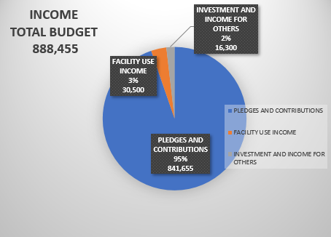
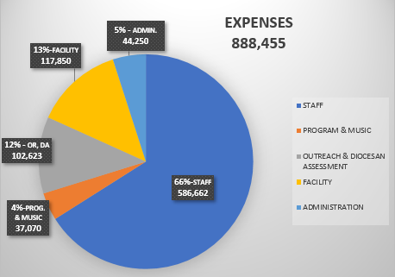
St. Paul’s Income & Expenses

