The First Sunday in Lent: The Face of Easter One
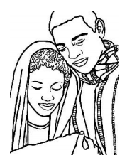
Jesus’ Birth and Growth
• I wonder if anyone in this family was ever born? I wonder what that amazing day was like? (Take this opportunity to tell birth stories as a family.)
• I wonder if there is anything in our house that we could bring to this story to help us tell it better? (Bring baby photos, perhaps figures from your nativity
set, etc.)

The Second Sunday in Lent: The Face of Easter Two
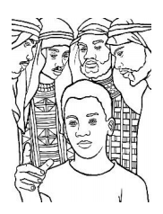
Jesus is Lost and Found
• I wonder if anyone in this family has ever been lost? (Share stories of times when you were lost, or when you thought you were lost.)
• I wonder if anyone in this family has ever been found? (Share stories about how you were found or people who helped you. Include stories, when appropriate, about how you found your partner, your calling, and more.)
• I wonder if there is anything in our house that we could bring to this story to help us tell it better?

The Third Sunday in Lent: The Face of Easter Three
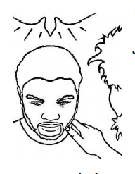
Jesus’ Baptism and Blessing by God
• I wonder if anyone in our family has been baptized? (Tell baptism stories. If you can, pull out the clothes your child wore, and talk about who was there that day, what you did to celebrate, etc.)
• I wonder if there is anything in our house that we could bring to this story to help us tell it better?

The Fourth Sunday in Lent: The Face of Easter Four
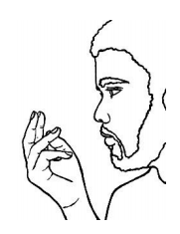
Jesus’ Desert and Discovery Experience
• I wonder if anyone in our family has ever wondered about who they are or what their work is going to be? (Tell stories about how you discovered your vocation, or maybe how you decided you wanted to be a parent. How did you know? Invite the children to dream about what their work might be now – being a friend, a sibling, an artist, a musician or what it might be when they grow up.)
• I wonder if there is anything in our house that we could bring to this story to help us tell it better? (If your work has special tools you could bring them to the story, or something that represents your work. What will the children bring?)

The Fifth Sunday in Lent: The Face of Easter Five
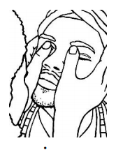
Jesus as Healer and Parable Maker
• I wonder if anyone in our family ever came close to God? I wonder if there are times when you felt like God was far away? (Share times in your own life when you felt close to God – at Church, in nature, when you were holding your child, etc. Also share those times when you did not feel close to God. Invite your child to do the same.)
• I wonder if there is anything in our house that we could bring to this story to help us tell it better? (Share photos of your favorite place to pray or feel close to God – your favorite beach, the church where you worship, etc.)
Palm Sunday: the Face of Easter Six
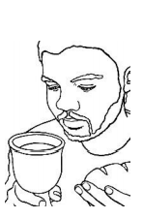
Jesus offers the Bread and Wine
• I wonder if anyone in this family ever discovered something new when sharing the Holy Bread and the Holy Wine? (Share stories about what feels most important to you when sharing communion. What part do you like best? What part seems most important? I wonder what other kinds of holy meals you share as a family? Special food? Special traditions at Christmas or Easter? What might make them holy or sacred?)
• I wonder if there is anything in our house that we could bring to this story to help us tell it better?

Easter Day: The Face of Easter Seven
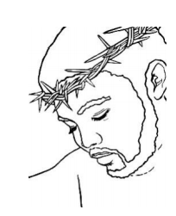 The One who was Easter and still is. 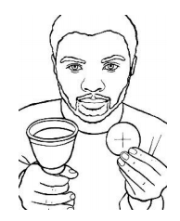
Special Note: These last two images are meant to be glued, back to back, so that the Face of Good Friday and the Face of Easter are always together. You cannot take them apart! After coloring the images, glue them together before sharing the story from the Parent Page.
• I wonder if anyone in this family has ever entered the Mystery of Easter? I wonder what you found? (Share stories about what you love about Holy Week and Easter. What is your favorite part? What part is most important? I wonder why? Invite your children to do the same.)
• I wonder if there is anything in our house that we could bring to this story to help us tell it better?

