2017-2018

**Support Our Concert Series—Become a Patron!**

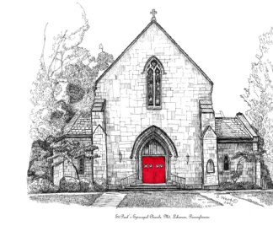**St. Paul’s Episcopal  
Friends of Music Guild**

**Concert Series Featuring:**

• **South Hills Organists**

**•Duo Cortado Guitarists**

* **Christin Cooper, Pianist**
* **Alexandra Thompson Cellist**
* **PSO Violin, Cello and Organ Chamber Music**
* **Mike’s Episcopal Café**
* **Lenten Organ Recitals**
* **Olga Redkina and Friends Recital**
* **Mt. Lebanon H.S. Choral Masterworks Concert**
* **Phil Solomon Steel Drum concert**

**1066 Washington Rd.  
Mt. Lebanon, PA 15228**

**Sunday, September 17, 2017 at 4:00pm**

**South Hills Organists Recital**

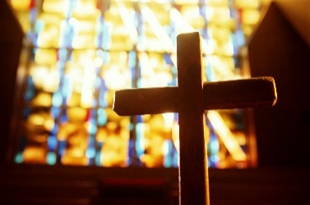

On Sunday September 17 at 4:00 pm, **South Hills Organists** will be playing their favorite organ works at St. Paul's Episcopal Church. Each recitalist will play 10-15 minutes on our wonderful Schantz organ. This year we welcome guests Aaron Sproul from St. Bernard, Cynthia Pock from First Lutheran, David Schaap from Trinity Episcopal Cathedral and Nicholas Will from St. Elizabeth Ann Seton Parish.

Free Will Donation

**Sunday, October 15, 2017**

**4:00pm**

**Duo Cortado, Guitarists**

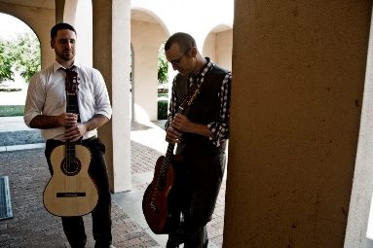

**Duo Cortado** (guitarists Andy Jurik and

Devin Sherman) presents a program featuring

new works for two guitars by Kevin Cope,

George Fetner, Zack Pentecost, and the

world-premiere of Thomas Dempster's '*twine'.*

The program also includes Paulo Bellinati's

*Jongo*, Mario Castelnuovo-Tedesco's *Fuga*

*Elegiaca*, and tunes from the Woody Allen

film *Midnight in Paris*. Find out more about

Duo Cortado at [www.DuoCortado.com](http://www.duocortado.com/).

Suggested Donation; $10

**Sunday, November 12 , 2017**

**4:00 pm**

**Christin Cooper, Pianist**

A person sitting in front of a piano

Description generated with very high confidence

Christin Cooper has just joined the staff of St.

Paul’s Episcopal Church as Assistant Music

Director for Children. Christin will perform

works for piano and collaborate with others

in her Pittsburgh Premiere!

Suggested Donation; $10



**Sunday, December 10th, 2017**

**4pm**

**Alexandra Thompson, Cellist**

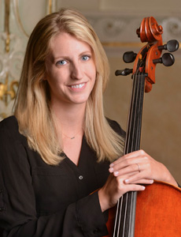 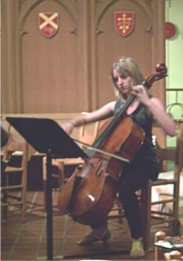

Cellist Alexandra Thompson, who attended

St. Paul's growing up and now plays in the

Pittsburgh Symphony Orchestra! She will perform an assortment of classical works and holiday favorites. Proud father and retired PSO member, Thomas Thompson will be in attendance with beautiful wife and singer, Christine Thompson.

Come join us for a most splendid concert!

Suggested Donation; $10

**Sunday, January 21, 2018**

**4:00pm**

**Chamber Music Concert**

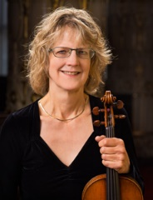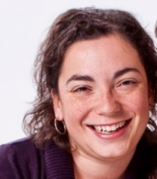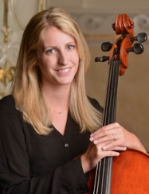

Pittsburgh Symphony Orchestra members Carolyn Edwards (violin) and Alexandra Thompson (cello) join Anne Carper Smith, organist at Bower Hill Community Church, to present a recital featuring duos by Kodaly, Saint-Saens, Rheinberger, and others. Please come and enjoy an hour of exceptional chamber music.

Suggested Donation; $10

**Saturday, February 17 , 2018**

**Mike’s Episcopal Café**

**6:30pm**

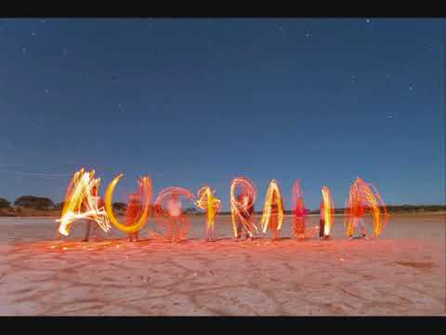

The Music Ministry presents its annual Fundraiser with gourmet of food and wonderful musical entertainment.

The theme will be “A Feast Down Under.” We

hope you’ll join us for an evening of tasty

Australian Cuisine, great music, and fellowship.

Details on cost and tickets will be forthcoming

in weekly announcements.

**Lenten Organ Recital Series**

**February and March 2018**

**12:30-1:00pm**

On Lenten Wednesdays at 12:30 pm, February 21 through March 7 Organists Richard Konzen, Doug Starr and Nicholas Will, will give a short program of organ works for Lent. All are welcome to attend.

*\*Wednesday, February 21 at 12:30-1:00pm*

*Richard Konzen, St. John’s Episcopal*

*\*Wednesday, February 28 at 12:30-1:00pm*

*Doug Starr, St. Paul’s Episcopal*

*\*Wednesday, March 7 at 12:30- 1:00pm*

*Nicholas Will, St. Elizabeth Ann Seton*

Free Will Offering

**Sunday, March 11, 2018**

**4:00pm**

**Olga Redkina and Friends**

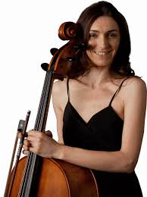

Cellist, Olga Redkina and friends will be in recital. Her concert will be SKYPED to her international roster of students. More about Olga can be found at her website: <https://www.olgaredkina.com>

Suggested Donation; $10

**Wednesday, April 4, 2018**

**7:30pm**

**Mt. Lebanon High School Choir**

**Masterworks Concert**

**Ethan LaPlaca- Director**

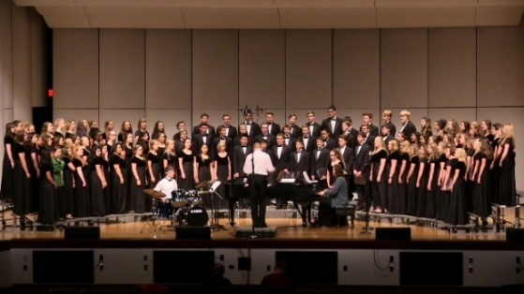

*featuring* Mt. Lebanon High School's Concert Choir, Chamber Choir, Triple Trio, and Men's Ensemble. They will delight us with their choice of musical choral masterworks.

Free Will Offering

**Sunday, May 20, 2018**

**4:00 pm**

**Phil Solomon and Friends**

**Concert of Island-style Steel Band**

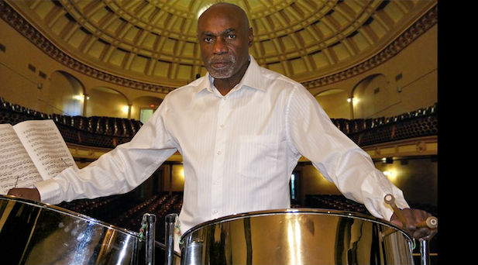

Born in British Guyana, Phil Solomon Steelpan builder, composer, arranger and innovator started making musical toys from tin cans at the age of seven. He would gather cans of all sizes and hammer them until they make different sounds. Phil became interested in music as a teenager and after hearing his first steelband decided that making, playing, arranging and composing for steelbands would be his lifelong commitment. Today, Phil Solomon performs every genre of music and his company Solomon Steelpan not only supplies Steelpans worldwide but also works with community based organizations, using them, as a means of engaging young people in music.

Suggested Donation; $10